Glados

Amazon Connect - Omnichannel cloud contact center.

Key Features

* Self-service configuration
* Dynamic, personal and natural contact flows
* Open platform
* Integrates with the aws ecosystem

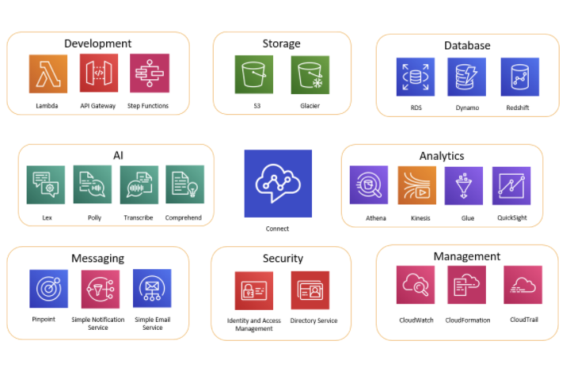

Development

Utilizing AWS Lambda interact with other services as needed.

Storage

Amazon connect uses Amazon S3 to store recorded conversations and exported reports.

Upon setting up Amazon Connect it creates a default buckets for these requirements. You can also point it to existing infrastructure in S3.

**VPC endpoints are not supported**

You can also manage the Amazon S3 policies to move data to Amazon S3 Glacier for less expensive long-term storage in amazon connect. However it breaks the link in the contact record in Amazon Connect. To fix this, use a Lambda function to rename the S3 Glacier object to match the data in the contract record

NOTE*

* What are the S3 policies we are going to need for conversation storing.
* Lambda function to update the names in S3 to match Amazon Connect upon moving the record to Glacier.

Database

You can use any AWS database with AWS Connect

* You can also create tables of dynamic information for call routing. For example, a Lambda function can write inbound calls to a DynamoDB table, then query the table to see if there are other matches for the phone number. If so, a decision can be made to send the caller to the same queue as before, or to flag them as a repeat caller.

Analytics tracks all interactions using **contract records.** Contact records are used ofr realt tiem and historical metrics reports.

You can also use Amazon Kinesis to stream them to an AWS database like Redshift or Athena for Business Intellegence Analysis you can use QuickSight and Tableu.

There are AWS CloudFormation templates available to set up this functionality for Amazon redshift and athena.

To perform analysis on your contact flow logs you can set up an amazon kinesis stream to stream your contact flow log data from cloudwatch to a data warehouse service scah as redshift

You have to integrate Amazon Lex, Amazon lets creates a chatbot to use as interactivevoice response for information

Messaging:

Pinpoint, SNS => SMS, SES

Chat Specific

Amazon Connect Chat enables your customers to start chatting with contact center agents from any of your business applications, web or mobile. Interactions are asynchronous, enabling customers to start a chat with an agent or amazon lex bot, step away from it, and then resume the conversation. They can even switch devices and continue the chat.

Agents have a single user interface to help customers using both voice and chat.

Pricing: <https://aws.amazon.com/connect/pricing/>

Getting Started With Chat

Enable chat at the instance level by creating an amazon s3 bucket for storing chat transcripts

<https://docs.aws.amazon.com/connect/latest/adminguide/amazon-connect-instances.html#get-started-data-storage>

Adding chat to your agent’s routing profile

<https://docs.aws.amazon.com/connect/latest/adminguide/routing-profiles.html>

Amazon Connect Chat ( ChatJS )

<https://github.com/amazon-connect/amazon-connect-chatjs>

<https://www.npmjs.com/package/amazon-connect-chatjs>

Example Async Customer Chat UX

<https://github.com/amazon-connect/amazon-connect-chat-ui-examples/tree/master/cloudformationTemplates/asyncCustomerChatUX>

Amazon Connect Chat UI Examples

<https://github.com/amazon-connect/amazon-connect-chat-ui-examples/tree/master/cloudformationTemplates/startChatContactAPI>

Tasks:

Amazon Connect Tasks allows you to prioritize assign track and even automate tasks across the disparate tools agents use to support customers.

Important Chat API routes

Question what is the difference between a customerChatSession vs a agentChatSession

Customer Chat Session is only when connecting a customer to an agent, the agent chat session is when you want a custom agent solution outside of aws connect. This utilizes aws connect streams to help link in your custom solution to the aws connect services.